

Department of B.Sc. Computer Science and Engineering
Database Management Laboratory

A mini project report on
INTRUSION DETECTION SYSTEM

by
Muskan Gupta - 231627013

Certificate

This is certified that the mini-project entitled “Intrusion Detection System” submitted in partial fulfilment of the III Semester Mini-Project for Database Management System Laboratory is a result of bonafide work carried out by Miss. Muskan Gupta (231627013) during the academic year 2024-2025.

Examiner 1 Examiner 2

Index

S.NO. | TOPIC | PAGE NO.
 | Chapter 1: Introduction | 4
 | Chapter 2: Proposed Model | 6
 | Chapter 3: Implementation and Results | 12
 | Chapter 4: Review of Current Intrusion Detection Approaches | 17
 | Chapter 5: Conclusion | 19

Chapter 1: Introduction

1.1 Overview of the Intrusion Detection System (IDS) Project
In today’s digital landscape, the security of network systems is crucial to protecting both organizational and personal data. As cyber threats become increasingly sophisticated, Intrusion Detection Systems (IDS) have emerged as an essential tool in network security, providing organizations with the means to detect unauthorized access, identify malicious behaviour, and respond proactively to potential cyber threats. This project is a comprehensive IDS solution designed to enhance security measures by detecting and analyzing anomalous network activities in real time.
The IDS project is built with a multi-layered architecture, incorporating a responsive frontend developed using HTML, CSS, and JavaScript, alongside a robust backend system powered by PHP and MySQL, operating within a XAMPP environment. This layered structure enables efficient data processing, streamlined user interaction, and thorough threat analysis. With an intuitive user interface (UI) and integrated data visualization, the IDS system allows users to efficiently monitor and understand network activities, thus enhancing security management. Through secure APIs, data synchronization between the frontend and backend is achieved, ensuring that real-time updates on detected threats are communicated to users without delay.
This IDS is designed not only to identify common cyber threats, such as Denial of Service (DoS) attacks and Brute Force attempts, but also to provide users with detailed information about each detected threat. The system’s “Know More” feature dynamically queries the database for historical threat data and insights, supporting informed responses and ongoing education about various cyber threats. By leveraging modern database management practices, data encryption, and secure access protocols, this project seeks to establish a robust and adaptable IDS solution that can respond to both known and unknown cyber risks.
1.2 Problem Statement
While IDS solutions have become standard in organizational cybersecurity protocols, their effectiveness often depends on how well they are managed and configured. Many IDS systems struggle with high volumes of false positives, causing alert fatigue among security teams and diverting attention from genuine threats. Moreover, the rapid evolution of cyber threats requires IDS systems to be adaptable and capable of recognizing both known attack patterns and novel, anomalous behaviors.
This IDS project addresses these challenges by developing a streamlined, user-friendly, and efficient system that minimizes false positives and enhances threat detection accuracy. By leveraging pre-defined pattern recognition algorithms and machine learning capabilities, the system is designed to accurately identify potential threats while minimizing the noise generated by false alarms. The integration of user authentication, data visualization, and real-time data processing further enhances the system’s usability and effectiveness. This project thus aims to offer an IDS solution that is not only accurate and responsive but also easy to manage and understand.
1.3 Project Objectives
The primary objective of this IDS project is to develop an effective and manageable intrusion detection solution that enhances cybersecurity efforts by accurately identifying and responding to cyber threats. Specific objectives include:
- Enhancing Threat Detection Accuracy: By reducing false positives and implementing rule-based and anomaly detection algorithms, the IDS is designed to identify genuine threats while minimizing unnecessary alerts.
- Facilitating User Interaction: A user-friendly interface and visualization tools enable users to easily access, interpret, and act on network threat data.
- Securing User Authentication and Data Privacy: Through salted hashing, secure HTTPS protocols, and API endpoint protection, the IDS ensures secure user authentication and data handling.
- Integrating Threat Knowledgebase: The “Know More” feature provides users with comprehensive insights into detected threats, supporting informed decision-making and increasing awareness of cybersecurity best practices.

This chapter has introduced the IDS project, its purpose, and its significance in cybersecurity. In a world where digital systems are essential to daily operations and data security is paramount, an efficient and responsive IDS is a critical component of organizational security infrastructure. By focusing on accurate threat detection, user-friendly interfaces, and secure data handling, this IDS project addresses key challenges in the field and provides a scalable, adaptable solution for proactive cyber threat management. The following chapters will provide a detailed overview of existing systems, an in-depth look at the system’s architecture and design, and the practical implementation of the IDS solution.

Chapter 2: Proposed Model

2.1 IDS System Architecture and Entity Relationships
The Intrusion Detection System (IDS) project is built on a relational database architecture designed to manage and analyze network security data, user information, and detected threats. The core components of this architecture are User, Network Security Log, Attack Type, and Incident Report. Relationships and constraints are applied to ensure data consistency, security, and efficient retrieval.
- User: Represents individuals interacting with the IDS platform, including both end-users and administrators. Attributes like UserID, Username, PasswordHash, Role, and LastLogin are stored here. Roles define permissions, with administrators managing configurations and standard users viewing alerts. Passwords are securely stored with salted hashes for protection against unauthorized access.
- Network Security Log: Core data source for intrusion detection, storing network traffic data with attributes like LogID, Timestamp, SourceIP, DestinationIP, Protocol, and LogSource. Automated monitoring populates these logs, which are structured to capture key details for precise threat detection. Indexed fields like Timestamp and SourceIP support efficient query performance for real-time and historical data retrieval.
- Attack Type: Catalogs cyber threats the IDS can detect, with attributes such as AttackTypeID, AttackType, Description, SeverityLevel, and DetectionMethod. This classification helps the system assess and provide detailed information on detected incidents.
- Incident Report: Acts as a record for each detected attack, with attributes like IncidentID, LogID, ReportedTimestamp, ResolutionStatus, and Notes. Each report links to Network Security Log and Attack Type, maintaining a historical record of incidents and their resolutions, which aids in threat analysis and tracking recurring vulnerabilities.
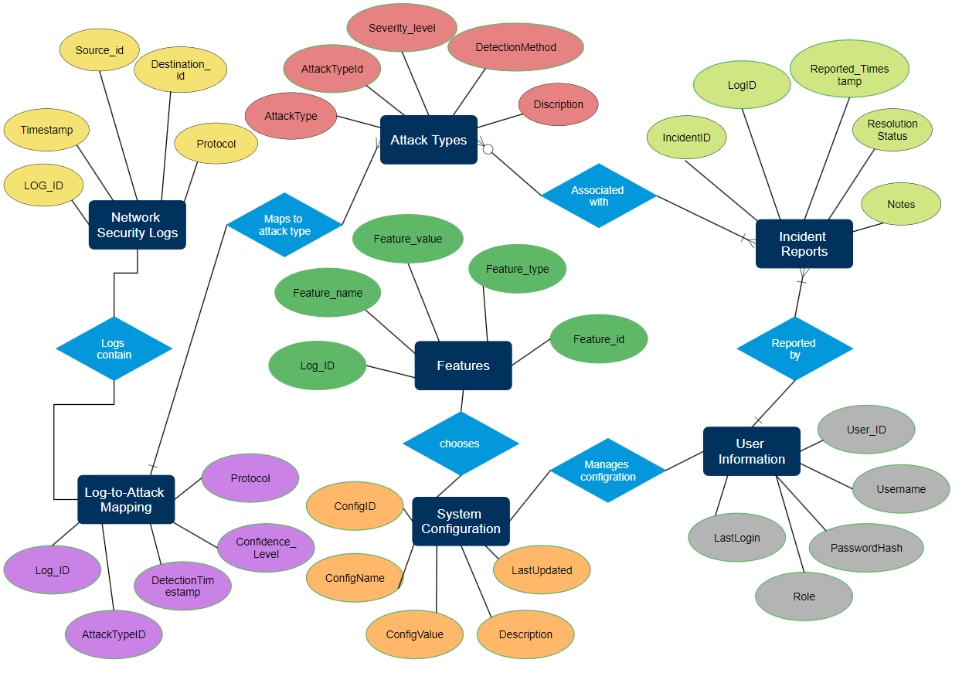
2.2 Entity Relationships and Constraints:

The ER diagram illustrates the database structure, showing the relationships among the core entities in the IDS system. Primary keys, foreign keys, and relational links are shown, highlighting the connections that enable comprehensive data management across user information, network logs, threat detections, and incident reports.
The IDS database employs a range of relationships and constraints to maintain data integrity and consistency:
- Log-to-Attack Mapping: The LogToAttackMapping table forms a bridge between Network Security Logs and Attack Types, logging every instance where a network activity matches a predefined attack pattern. Foreign keys (LogID and AttackTypeID) ensure that each mapping has valid references to existing logs and attack types, reinforcing referential integrity. The ConfidenceLevel attribute in this table quantifies the probability of detection accuracy, enabling refined threat assessments.
- User-Log Relationship: Each log entry can be linked to a specific user action, especially in cases of internal network monitoring where user-triggered events are logged. This relationship, represented in the UserInformation table and referenced in logs, allows administrators to trace actions to specific users, enabling accountability and faster response to potential insider threats.
- Incident Reporting Constraints: Incident records reference Network Security Logs through a LogID foreign key and enforce constraints that prevent deletion of related logs without corresponding incident updates. This ensures that the system maintains a complete history of all detected incidents, critical for post-incident analysis and legal compliance.
These entity relationships collectively ensure that logs, threats, and user actions are consistently tracked, providing a robust framework for real-time threat monitoring and historical data analysis
2.3 Database Design
Relational Database Schema
The IDS database schema is designed to handle the complexities of network security monitoring efficiently. Key tables include NetworkSecurityLogs, AttackTypes, Features, UserInformation, and IncidentReports. These tables are structured to store essential security information and facilitate rapid data retrieval, supporting the IDS's real-time analysis requirements.
- NetworkSecurityLogs: Stores individual network logs, with LogID as a primary key and fields like Timestamp, SourceIP, and Protocol. Each log entry provides foundational data for identifying potential threats.
- AttackTypes: Contains a list of potential cyber threats, each assigned a unique AttackTypeID. The table includes Description and SeverityLevel fields, which are referenced in both mapping and incident tables, providing clarity on the nature and risk level of each threat.
- Features: The Features table stores individual characteristics or metrics extracted from network logs, such as packet size or connection duration. It links to NetworkSecurityLogs through LogID and categorizes each feature, enhancing pattern recognition and threat detection by analyzing various log attributes.
- UserInformation: The UserInformation table holds user credentials, roles, and login data, linking user actions to network logs, if applicable. Secure hashing mechanisms for the PasswordHash attribute add an essential layer of security, safeguarding user credentials.
- IncidentReports: This table is dedicated to documenting each detected attack, recording IncidentID, associated LogID, and details on resolution status. This design allows for a structured review process, enabling systematic incident management.
Foreign Key Constraints
To preserve data integrity and support reliable data relationships, foreign keys are used extensively across tables:
- LogToAttackMapping: Links NetworkSecurityLogs and AttackTypes via LogID and AttackTypeID, ensuring that each threat identified has a corresponding log entry and classification.
- IncidentReports: Relies on LogID to link detected attacks back to specific logs, maintaining historical accuracy. This constraint prevents data anomalies and maintains traceability for all incident records.
Through these foreign keys and relationships, the IDS database can efficiently cross-reference data points across multiple tables, preserving data accuracy and integrity for all interrelated entries
2.4 Project Workflow
The workflow of the IDS system encompasses several stages, from user authentication to real-time threat detection and detailed threat analysis.
- System Workflow:
  - User Login: Users initiate interaction with the system by logging in through a secure interface. Once authenticated, the user’s role determines access levels, with administrators having configuration capabilities.
  - Log Submission: Network data is continually logged or manually submitted by users. Once logs are added, they are parsed and checked for potential threats.
  - Real-Time Detection and Feedback: Submitted logs undergo immediate analysis by machine learning algorithms, identifying patterns indicative of cyber threats. Detected threats trigger alerts that are displayed on the user’s dashboard for immediate review.
- Threat Detection and Analysis:
  - Attack Identification: The IDS applies pattern recognition to network logs, using both heuristic and signature-based methods. Common threats like Denial of Service (DoS) or SQL Injection are detected through characteristic patterns in log data, while complex threats rely on multi-dimensional analysis across fields stored in the Features table.
  - Threat Categorization: Detected attacks are categorized by severity, aiding users in prioritizing responses. For instance, high-severity threats like malware or DoS attacks prompt immediate alerts, whereas medium-severity issues like phishing are displayed for further review.
  - Continuous Monitoring and Updates: The system regularly scans and updates threat classifications and detection algorithms to address evolving cyber risks. This adaptive approach ensures that the IDS remains effective against new threat vectors, enhancing resilience against emerging cyberattacks.
This workflow allows for seamless integration of user interaction, log management, and threat detection, ensuring that the IDS delivers timely and actionable security insights. With its data-driven architecture, robust database design, and structured workflows, the IDS system is well-equipped to address modern cybersecurity challenges.
2.5 Methodology and Approach
The methodology and approach for this Intrusion Detection System (IDS) are structured to deliver a comprehensive, secure, and user-friendly experience. The approach encompasses frontend and backend development, real-time threat detection, secure data handling, and multi-layered protection to ensure seamless user interactions and efficient threat monitoring.
2.5.1 Frontend Development and User Interface
The frontend of the IDS is developed using HTML, CSS, and JavaScript to provide a responsive, cross-platform user interface that ensures compatibility across devices and browsers. The core aspects of the frontend methodology include:
- User Authentication: At the entry point, users are required to authenticate their credentials through a secure interface. HTTPS protocols and salted hashing algorithms are implemented to protect user data, ensuring that login information remains encrypted and safeguarded against unauthorized access.
- Interactive Dashboard: Once authenticated, users access a dashboard, the primary control centre for all IDS operations. Designed with an intuitive layout, the dashboard allows users to input IP addresses, submit network logs, and access analysis tools. The interactive design reduces complexity and helps users easily navigate between sections.
- Data Visualization: JavaScript libraries such as Chart.js are utilized for dynamic, real-time visualization of attack patterns and logs. These libraries enable rendering of graphs and charts that help users understand threat data at a glance, providing both high-level overviews and detailed insights into detected threats.
2.5.2 Backend Development and Core Functionality
The backend, powered by XAMPP and structured with PHP and MySQL, acts as the operational core of the IDS. The backend architecture is optimized to support high-frequency data processing, enabling efficient data storage, analysis, and retrieval. Key backend functionalities include:
- Data Storage and Indexing: IP addresses, network logs, and detected threats are stored in structured tables, utilizing indexed databases to ensure fast querying and retrieval. Indexed fields like Timestamp and SourceIP improve the speed of database operations, which is essential for real-time threat detection.
- Pattern Recognition and Threat Detection: The system employs pattern recognition algorithms and pre-trained machine learning models to identify anomalies in network traffic. Analyzing log data for unusual patterns or deviations from normal behavior allows the IDS to detect potential threats efficiently. The detection layer is optimized for minimal latency, ensuring real-time responses to threats.
- "Know More" Feature: The backend hosts a dynamic "Know More" feature that allows users to query comprehensive threat information, providing insights into each detected attack. This feature retrieves historical records, threat descriptions, and prevention guidelines directly from the database, equipping users with relevant information to respond effectively.

This methodology establishes a holistic approach to intrusion detection, combining secure data handling, real-time monitoring, and a user-friendly interface. By integrating the frontend with a robust backend through secure APIs, leveraging data visualization for intuitive user insights, and implementing multi-layered security, the IDS project is well-equipped to handle modern cybersecurity challenges. This multi-layered design not only fortifies the system against internal and external threats but also provides a data-driven solution for proactive threat detection and mitigation.

Chapter 3: Implementation and Results

3.1 Frontend and Backend Integration
The implementation of the Intrusion Detection System (IDS) required a cohesive integration of the frontend and backend to provide a secure, responsive, and user-friendly experience. This integration enabled real-time data handling, interactive user feedback, and comprehensive threat visualization.
- Frontend
The user interface, developed with HTML, CSS, and JavaScript, facilitates seamless data input, visualization, and authentication. Key aspects of the frontend include:
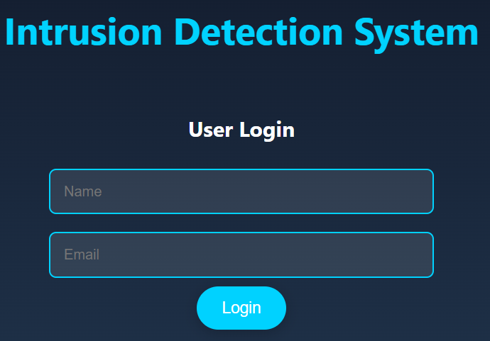
  - User Authentication: The login page requires users to authenticate their credentials securely before accessing the IDS features. HTTPS encryption and salted hashing algorithms are applied to protect login data.

  - Data Input and Submission: Users can input IP addresses and network logs directly into the IDS dashboard, making it simple to submit data for real-time analysis. The interface supports form validation to ensure input accuracy and consistency.
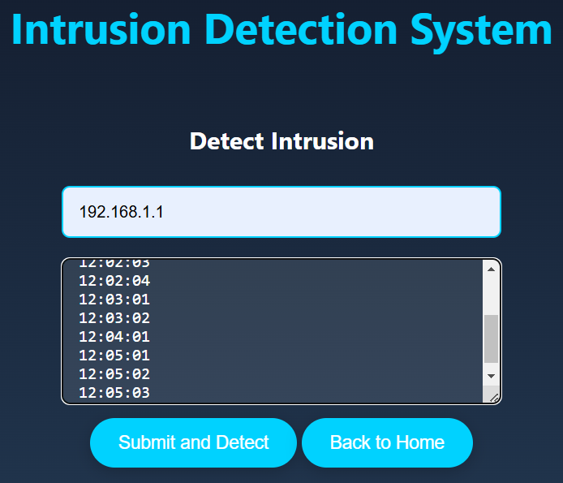

  - Visualization Dashboard: JavaScript libraries such as D3.js and Chart.js were utilized to create an interactive visualization dashboard. Detected threats are represented graphically, with dynamic charts and graphs displaying information such as attack frequency, severity, and patterns.

- Backend
The backend, powered by PHP and MySQL on a XAMPP server, manages the IDS’s data processing, storage, and detection functionalities. Core backend implementations include:
  - Data Processing and Storage: Submitted network logs are processed and stored in structured MySQL tables with indexed fields for efficient querying. Key tables include NetworkSecurityLogs, AttackTypes, and IncidentReports, which are optimized for real-time retrieval.
  - Pattern Recognition and Anomaly Detection: The backend applies pre-trained pattern recognition algorithms to detect anomalies indicative of cyber threats. Detected threats are mapped to predefined attack types in the database, allowing for accurate and immediate categorization.
  - Secure API Endpoints: Secure API endpoints are configured to facilitate real-time, asynchronous communication between the frontend and backend. All data transactions are encrypted with HTTPS, ensuring secure data transmission.
3.2 Results and Visualization
The results from implementing the Intrusion Detection System (IDS) were gathered by simulating various attack scenarios and monitoring the system's ability to detect, categorize, and respond to each threat in real-time. The IDS's workflow, from user login to real-time threat detection and analysis, was systematically evaluated to ensure its effectiveness in identifying and categorizing network threats.
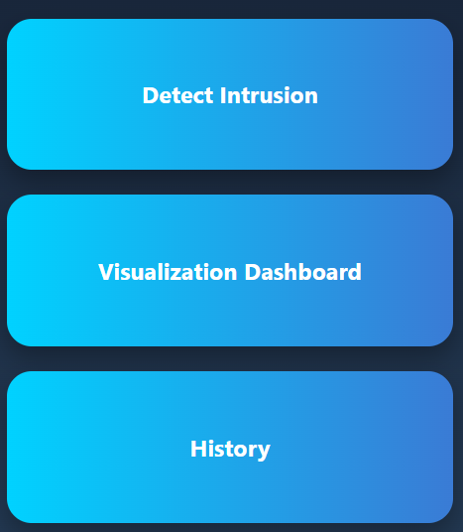
Home page:

Key findings from this evaluation are presented below, with visual data to support the analysis.
Visualization tools integrated with the IDS, such as D3.js and Chart.js, enabled dynamic representation of detected threat data, supporting deeper insights into threat patterns and helping users identify trends over time.
- Frequency of Attack Types
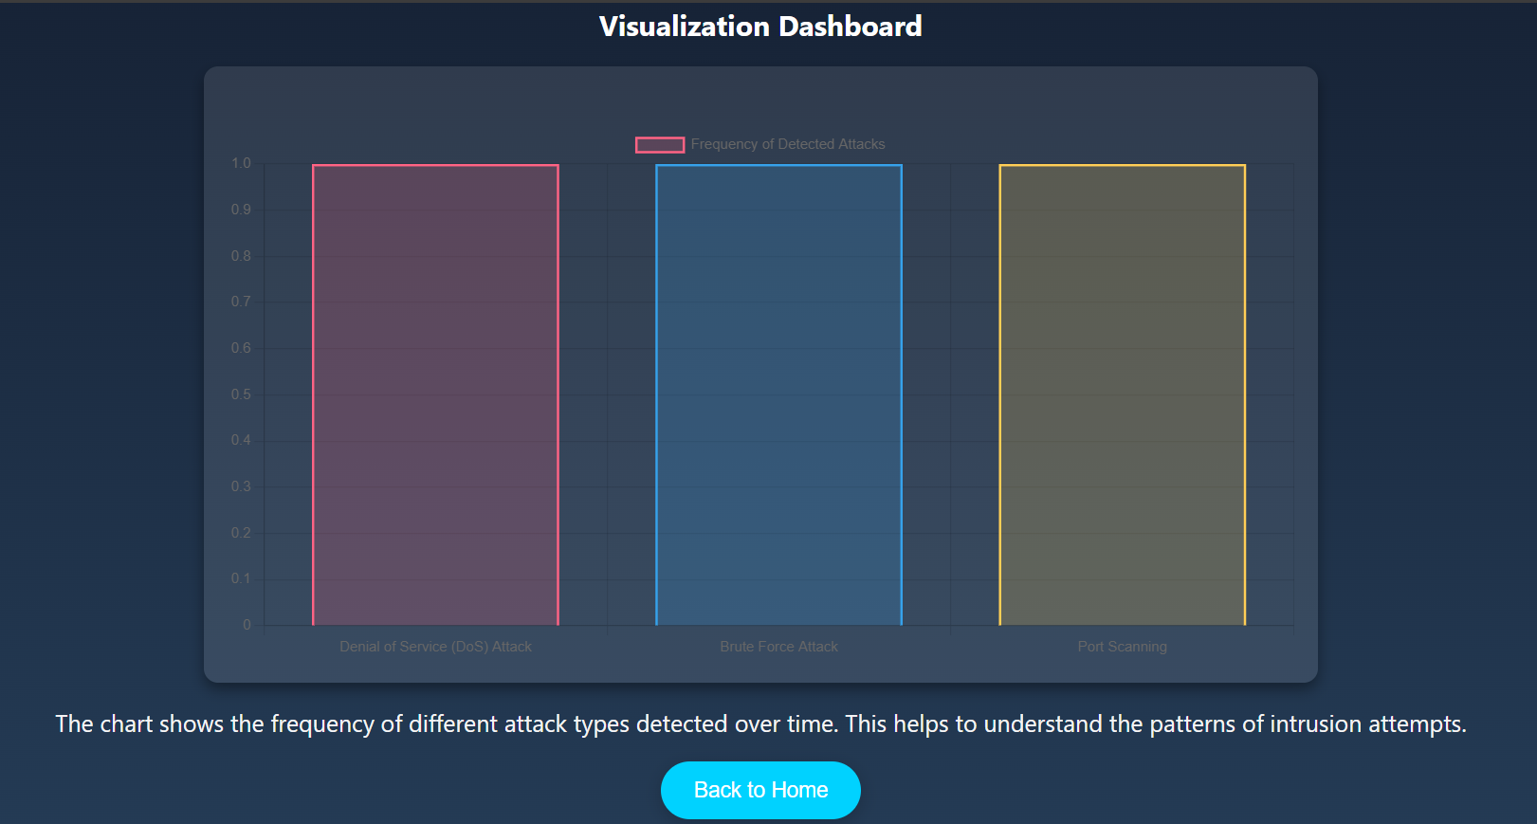
Bar Chart of Detected Attacks: A bar chart displays the frequency of each detected attack type, providing insights into the most common threats in the network environment. In testing, DoS and SQL injection attacks were observed as the most frequent types.


- User Interaction and "Know More" Feature

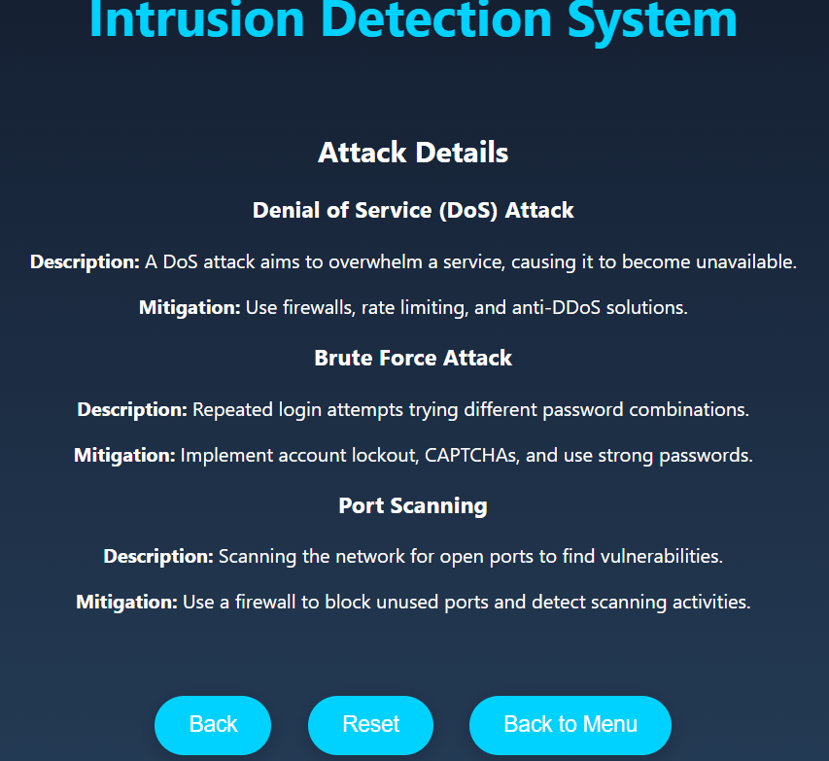

The "Know More" feature provided users with detailed information on detected threats, enhancing their understanding of each attack.
Users accessed threat-specific details, including severity level, historical occurrences, and prevention tips. This feature empowered users to act on alerts with well-informed responses, improving the overall user experience.
The feature enhanced user engagement and understanding of threats. This comprehensive evaluation supports the IDS’s viability as a proactive, user-friendly cybersecurity solution.
Through a combination of secure frontend-backend integration, simulated intrusion testing, and real-time visualization, the IDS project demonstrated its capability to detect and respond to network threats efficiently. The results underscore the system’s effectiveness in real-time threat monitoring, data-driven analysis, and user-friendly visualization, establishing a solid foundation for further refinement and practical deployment in cybersecurity environments.

Chapter 4: Review of Current Intrusion Detection Approaches

4.1 Existing Intrusion Detection Systems (IDS) and Their Challenges
Intrusion Detection Systems (IDS) play a critical role in organizational cybersecurity, aimed at detecting, alerting, and responding to unauthorized access and network anomalies. Traditional IDS solutions primarily use two approaches: signature-based and anomaly-based. Signature-based systems detect threats by comparing network data against known threat signatures, which makes them effective for identifying familiar threats. However, they often struggle with new or evolving attack types. Anomaly-based IDS, in contrast, can detect new or unknown attacks by identifying deviations from established network behaviors. Despite the strengths of both methods, each has limitations that affect their overall effectiveness.
One of the main challenges with existing IDS solutions is the high rate of false positives. Security teams frequently experience alert fatigue due to the sheer volume of alerts, many of which are not actual security threats. This high false-positive rate not only diverts attention from genuine threats but also places a heavy demand on resources and personnel. Additionally, IDS systems often lack interoperability with other security tools, which limits data sharing and integration into broader security protocols. This results in data silos, restricting the IDS's role in comprehensive threat management.
Another challenge lies in data security and privacy. Many IDS systems store sensitive data related to network activity and user behavior, raising concerns about data protection. Without adequate encryption and access control measures, IDS data can itself become a target for attackers. These limitations underscore the need for more adaptable, secure, and accurate IDS solutions that can effectively handle complex network environments without overwhelming security teams with false alerts.
4.2 Industry Trends in Intrusion Detection and Cybersecurity
With cyber threats growing in complexity, advancements in IDS technology are shaping modern cybersecurity practices. Two prominent trends include the integration of machine learning (ML) and the shift towards interoperable security ecosystems that enhance the IDS's functionality.
Machine Learning Integration: The use of ML, especially in anomaly detection, has shown significant promise in enhancing IDS capabilities. By analyzing historical network data, ML-based IDS solutions can detect subtle changes in network behavior, identifying potential threats as they emerge. This approach reduces false positives by refining the system’s understanding of normal network behavior, enabling the IDS to detect slight deviations that could signify an attack. Behavioral analysis is also increasingly applied, as IDS systems monitor user behavior patterns to identify potential insider threats or unusual access patterns, adding another layer to threat detection.
Interoperability and Centralized Security: Modern security infrastructures are evolving towards centralized platforms that enable various security tools—such as firewalls, IDS, and security information and event management (SIEM) systems—to share data. This integration allows for a comprehensive approach to threat analysis and enables more data-driven responses to security incidents. For example, if an IDS detects a suspicious login attempt, it can share this information with the SIEM, which then correlates it with other security data to provide additional context. By promoting connected security ecosystems, organizations can achieve a more robust defense against cyber threats.
4.3 Comparison of Proposed IDS Solution with Existing Systems
The proposed IDS solution addresses the challenges faced by traditional IDS systems by adopting industry best practices to enhance threat detection, reduce false positives, and improve usability. Traditional IDS solutions, while effective in basic threat detection, often lack the flexibility and user-friendliness needed for modern security needs. The proposed IDS solution employs a multi-layered approach that combines rule-based detection with pattern recognition techniques. This enables the system to detect both familiar and emerging threats more accurately, reducing the likelihood of missed detections and false positives.
A unique aspect of the proposed IDS solution is its "Know More" feature, which provides users with detailed information about each detected threat. This feature enables users to understand the nature, history, and severity of the threat and offers recommended prevention strategies. This knowledge base not only makes the IDS more informative but also empowers users with critical information to stay ahead in a rapidly evolving threat landscape.
Another strength of the proposed IDS solution is its emphasis on secure, seamless frontend-backend integration, which enables real-time communication and data sharing. This real-time functionality ensures that users receive immediate feedback on detected threats, facilitating proactive responses. The solution utilizes secure API endpoints, encrypted user credentials, and HTTPS protocols, prioritizing data security and protecting against common vulnerabilities like SQL injection and cross-site scripting (XSS).
In terms of usability, the proposed IDS solution features an intuitive interface that allows users to navigate efficiently between detection, analysis, and visualization pages. This streamlined design reduces the learning curve for new users, enabling them to interact effectively with the system.
This chapter has reviewed the state of existing IDS systems, highlighting primary challenges like high false-positive rates, data silos, and limited interoperability. The review also discussed industry trends, such as the growing use of machine learning for anomaly detection and the shift toward centralized, interoperable security infrastructures. These trends emphasize the need for adopting a multi-layered and data-driven approach to intrusion detection.
The proposed IDS project, by incorporating advanced detection techniques, secure data handling, and user-centric design, presents a forward-thinking solution that addresses these challenges. It focuses on accuracy, user experience, and secure data management, offering a comprehensive IDS solution that extends beyond basic threat detection, equipping users with the tools to manage security threats proactively.

Chapter 5: Conclusion
5.1 Recapitulation and Significance
The Intrusion Detection System (IDS) project demonstrates a robust approach to modern cybersecurity challenges by offering an effective, real-time solution for monitoring and detecting network threats. Built on a multi-layered architecture that combines frontend and backend integration, pattern recognition, and user-friendly visualization, this IDS successfully provides proactive threat detection, enhanced security, and significant usability for users and administrators alike.
The project achieved key objectives, such as implementing an efficient detection mechanism, reducing false positives, and ensuring secure data handling across the platform. The frontend design, developed with HTML, CSS, and JavaScript, allows for easy data input, interaction, and visualization of threats through libraries like D3.js and Chart.js. This interactive setup enables users to make informed decisions quickly, minimizing the time taken to understand and respond to security threats. The backend structure, powered by PHP and MySQL, serves as the operational core, handling high-frequency log processing, pattern recognition, and secure data storage. By using encrypted API endpoints and multi-layered security protocols like HTTPS, input validation, and password hashing, the project ensures the integrity and confidentiality of user data, reinforcing the IDS’s role in safeguarding digital assets.
In practice, the IDS’s effectiveness was validated through simulated intrusion scenarios, where it successfully identified known cyber threats such as DDoS attacks, SQL injection, and cross-site scripting (XSS), among others. These tests confirmed the system’s ability to detect familiar threats with accuracy and respond in real time, as well as its resilience against various cyberattacks. Additionally, by minimizing false positives and optimizing performance through database indexing and asynchronous data handling, the IDS maintains a high standard for detection reliability and system responsiveness. This achievement signifies the project’s contribution to cybersecurity, as it provides a reliable defense mechanism that organizations can leverage to protect their networks from evolving threats.
5.2 Charting the Path Forward
While the IDS project demonstrates a foundational solution for cybersecurity, future enhancements could expand its capabilities to keep pace with increasingly sophisticated cyber threats. Integrating machine learning (ML) would be a key step forward in refining threat detection accuracy. By using ML algorithms, the IDS could evolve from detecting known threat patterns to identifying complex, previously unseen behaviors based on historical data and real-time analysis. Supervised and unsupervised ML models could enable anomaly-based detection with higher precision, further reducing false positives and broadening the system’s adaptability.
Cloud compatibility represents another significant enhancement. With the growing adoption of cloud-based infrastructures, making the IDS cloud-compatible would extend its reach and improve scalability. Cloud compatibility would allow for the IDS to monitor and analyze network activity across multiple environments, including on-premises and cloud-hosted networks. This enhancement would benefit organizations operating on hybrid infrastructures by enabling a centralized security solution that adapts to their diverse environments.
Moreover, integrating the IDS with broader cybersecurity frameworks, such as Security Information and Event Management (SIEM) systems or Threat Intelligence Platforms (TIPs), would establish a more holistic security environment. By feeding IDS data into a SIEM, for example, organizations could achieve a comprehensive view of their security landscape, with alerts and threat data from the IDS contextualized alongside information from other security tools. This integration would enable the IDS to contribute to advanced analytics, threat intelligence sharing, and enhanced response coordination, fortifying overall cybersecurity strategy.
5.3 Final Note
In today’s digital landscape, an Intrusion Detection System (IDS) is an indispensable tool in the fight for digital safety. The IDS project underscores the critical need for innovative, data-driven, and user-friendly security solutions. As cyber threats evolve, so must the tools designed to detect and mitigate them. This IDS project exemplifies the importance of continuous innovation, pushing forward not only on technology but also on design that empowers users to interact with security data effectively and confidently. The need for reliable, real-time detection and user accessibility remains vital as organizations face increasingly complex and frequent cyber risks.
The IDS project, with its strong foundation and forward-thinking approach, sets the stage for the next generation of cybersecurity tools, integrating emerging technologies with a commitment to data security and user-centric design. This project highlights that, in an era of rapid digital transformation, developing effective IDS solutions is not only beneficial but essential, serving as the frontline in protecting networks, data, and users from the dynamic threat landscape.

